3
Numerical descriptives in R
In R, to obtain many of the descriptive statistics that we have covered here you can use the methods we described in Chapter 2 to obtain the summary statistics.
First of all you need to load your data into R for analysis. You can do this using either Excel and loading this in, or using the <- c command both of which we showed you in Chapter 2. To use the <-c command you can load the coping scores for the heart attack and stroke patients illustrated in Chapter 3 as follows:

CopingScore <-c(39,26,26,9,14,28,21,26,23,18,27,1,25,23,23,40,9,13,13,21, 27,29,27,27,33,22,29,23,29,30,27,23,26,35,25,32,32,22,25,30)
Patient <-c(1,1,1,1,1,1,1,1,1,1,1,1,1,1,1,1,1,1,1,1,2,2,2,2,2,2,2,2,2,2,2,2,2,2,2,2,2,2,2,2)

Remember from Chapter 2 you need to let R know that the Patient variable is a categorical variable. To this you need to type in the following:

Patient <- factor(Patient)
Of course, you could also follow the instructions in Chapter 2 and load the data in from an Excel file.

We have loaded our data in to R. Let us now look at generating some basic descriptive statistics. For many of the descriptive statistics that we covered in Chapter 3 we advised that you load up the psych package. You should have already downloaded this package following the instructions in Chapter 2. However, this does not mean that the analyses which form a part of the package are available every time you run R. In order to utilise these functions you need to load it into R every time you start an R session. To load the psych package you need to type the following onto the command line:

>library(psych)

Once you have called on the psych package you can then use the describe function to generate the descriptive statistics. So to generate descriptive statistics for the CopingScore variable you can type in:
>describe(CopingScore)
When you use this command, you will be presented with the output in Screenshot 1:

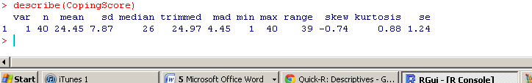
Screenshot 1

The statistics that are presented here are, the number of data points, the mean, the standard deviation, the median, trimmed mean, the median absolute deviation from the median, the minimum score, the maximum score, a measure of skewness, a measure of kurtosis and the standard error. The trimmed mean, the median adjusted deviation from the median, skewness statistic and measure of kurtosis are not directly covered in the book and so we advise that you refer to the R documentation for an explanation of these.

If you want the quartiles for your data you can use the summary function instead of the describe function:
>Summary(CopingScore)
When you use this, you will be presented with some summary statistics (Screenshot 2)
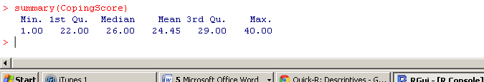
Screenshot 2

Sometimes you have a data file where you have a grouping variable where you are coding a number of separate groups (much as we have described in Chapters 2 and 3). To get the descriptive statistics for each group you can use the following command (remembering that you need to have loaded the psych package prior to doing this:

>describe.by(CopingScore, Patient)
The second variable in the brackets needs to be your grouping variable for this command to work. You will be presented with the information presented in Screenshot 3:

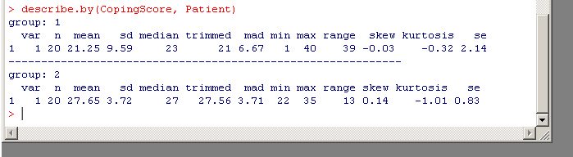
Screenshot 3

Generating bar charts in R
To generate a bar chart in R you can use the barplot() command. If you want the height of the bars to represent the frequency counts for each category, then you can use the Table command to get the frequency data into the correct format and then use the barplot() command to generate the bar chart. For example, let us use the data that we presented in Table 3.3 in the book. We have imported this into R and created a data frame called ‘Wellbeing’. You can then type in the following two commands to generate the bar chart which represent the frequency of occurrence of participants in the two patient groups (Screenshot 1):

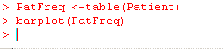
Screenshot 1

When you run these commands you will be presented with the bar chart presented in Figure 1:

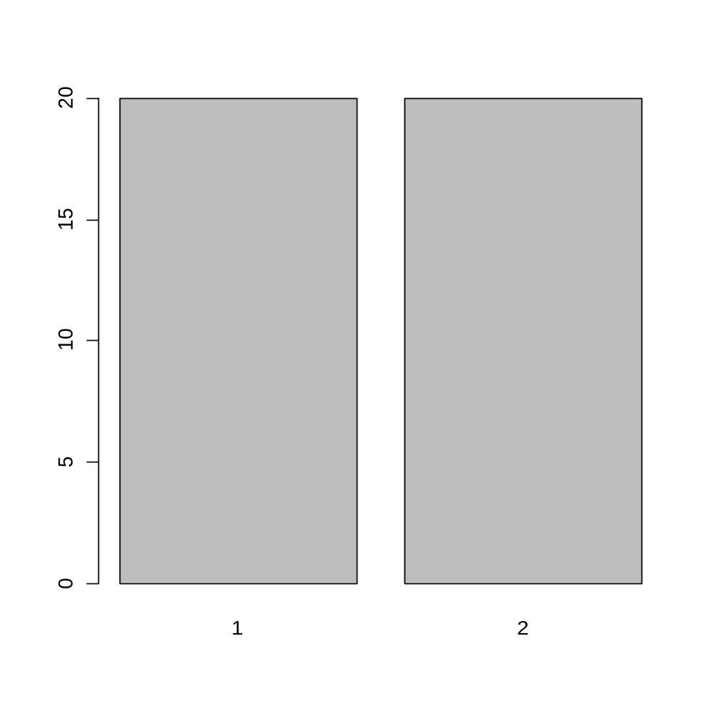
Figure 1

If you want your line graphs to represent other statistics such as means or medians, then you need to run a different command prior to the barplot()command. For example, if we wanted to generate a barplot of the means for coping scores for the two patient groups, we would need to use the aggregate() command. You would need to type out the command as follows:

>meanCoping <- aggregate(Coping, by=list(Patient), FUN= mean)

In this command, the variable that you need the means plotted for is the first named in the brackets; the categorical grouping variable is named in the list() part of the command and finally we name the function that we are plotting. You should note that FUN needs to be typed in uppercase. Once you have typed this in, you can use the barplot() command to plot the means. You need to type in the following:

>barplot(meanCoping$x, xlab=”Patient Group”)
We have to include the ‘$x’ bit of the command because the aggregate command sets up a table where the means are in a column called ‘x’. Thus to reference this column, we need the $x. When you use this command, you will be presented with the Screenshot in Figure 2

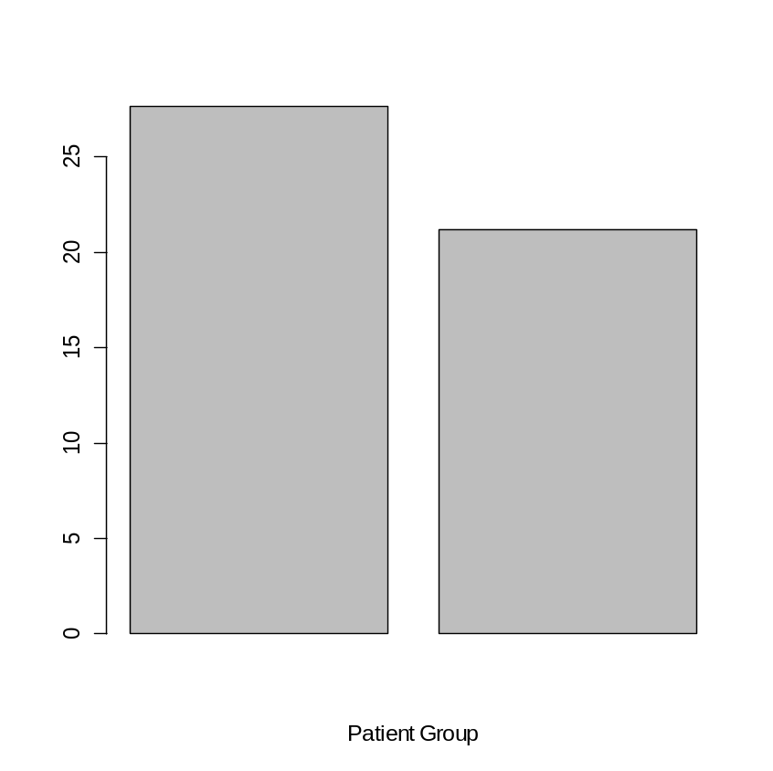
Figure 2

Generating line graphs in R
Generating line graphs in R is similar to generating bar charts. If you are plotting a line graph of means, you first need to generate the means in a table as we illustrated above for bar charts. Thus we would use the following command:

>meanCoping <- aggregate(Coping, by=list(Patient), FUN= mean)
We would then need to generate a plot which has the two means that we want to illustrate on. We can do this with the plot() command e.g.

>plot(meanCoping$x, type = “p”, xlab=”Patient Group”)

In this command the type=”p” tells R to plot the graph of the means. This will have the means of each condition indicated but have no line joining them. The xlab argument generates a caption on the x-axis. To complete the graph, we need to overlay the line that joins the two means. We can do this with the lines() command as follows:

>lines(meanCoping$x, type =”l”)
When you use these three commands together, you will be presented with the line graph shown in Figure 3:

1.0
1.2
1.4
1.6
1.8
2.0
21
22
23
24
25
26
27
Patient Group
Mean coping
Figure 3

Generating graphs with standard deviations in R

It is not easy to generate graphs with standard deviations in R and so we recommend simply generating graphs which have 95% confidence intervals on them instead. We give the instructions for producing these in the R guide to Chapter 4.

Generating frequency histograms in R
To generate a histogram of a variable in R, we can use the hist() command. Thus, to generate the histrogram for the ‘CopingScore’ data we can type in the following into R (assuming that we have used attach()to make the variables more readily available):

>hist(CopingScore)
When you do this you will be presented with the histogram shown in Figure 4.

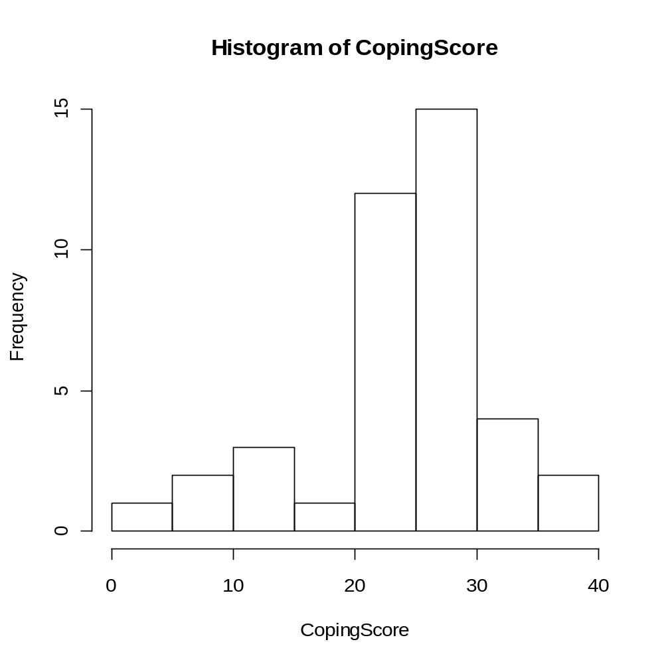
Figure 4

We should note here that we have glossed over a little issue with regards to generating the histogram for the stroke patients only. If you follow the instructions above, you will get a histogram which includes all the participants (both stroke and heart attack patients) mixed together. If you want to get the histogram separately for each patient group, you can use the histogram() command. However, this is in a separate package and so you need to load up the package using the library()command. The package we want is called ‘lattice’ and so you need to type in the following command:

>library(lattice)

Once you have done this you can type in the following command to generate the two histograms:

>histogram(~Coping | Patient)

When you type this in and press enter, you will be presented with the histograms in Figure 5:

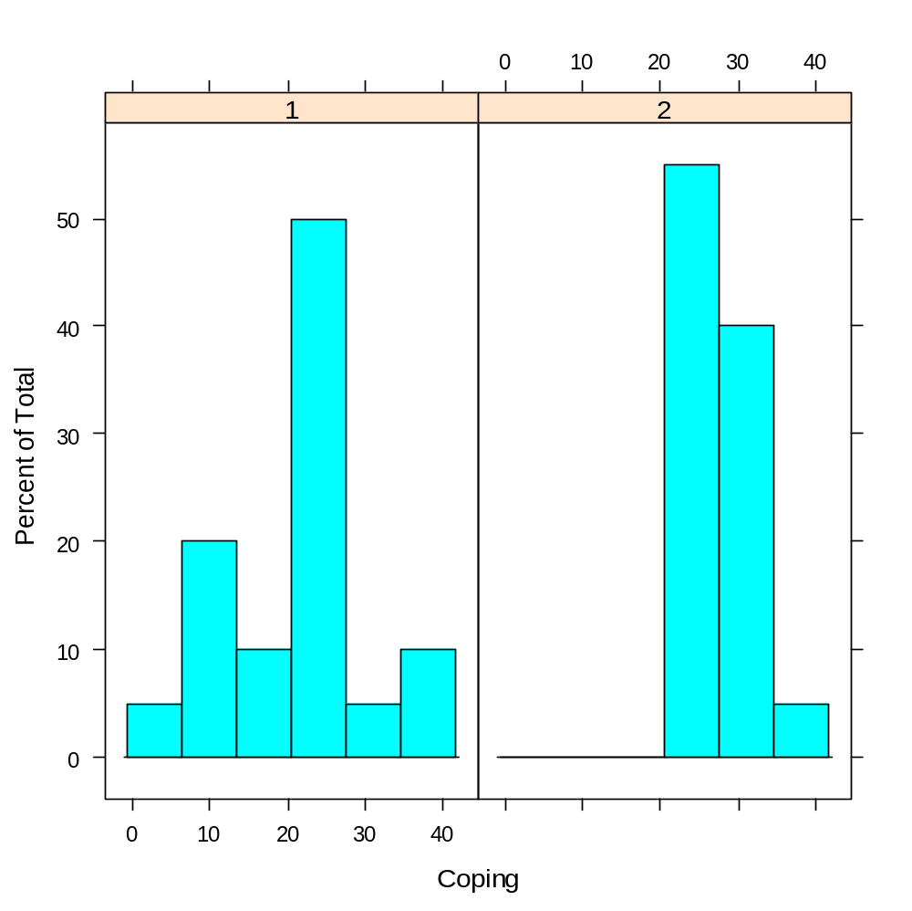
Figure 5

Generating box-plots using R
It is relatively straightforward in R to generate boxplots for single variables and also for a variable broken down by group. For this we use the boxplot() command. For example, we might type in the following to generate a boxplot for the Coping variable:

>histogram(Coping)
If you do this you will be presented with the histogram presented in Figure 6:

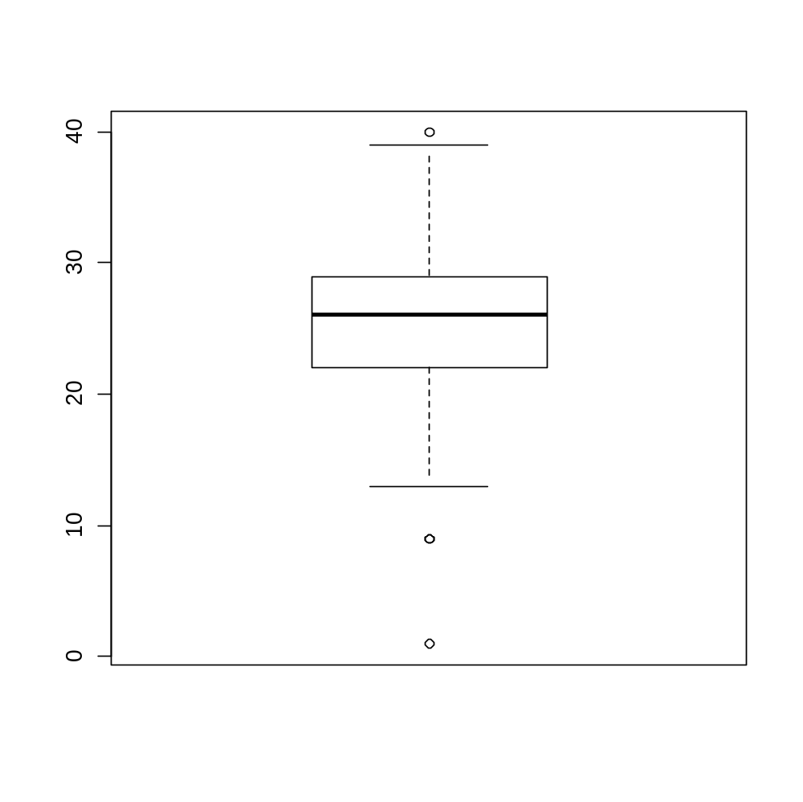
Figure 6
Here you can see that we have a number of outliers. This boxplot shows the Coping scores overall, that is not broken down by patient group. To get these plotted separately for each patient group, we need to type in the following instead:

>histogram(Coping~Patient)

In this the variable after the tilde (~) is the grouping variable. When you run this, you will be presented with the two boxplots given in Figure 7:

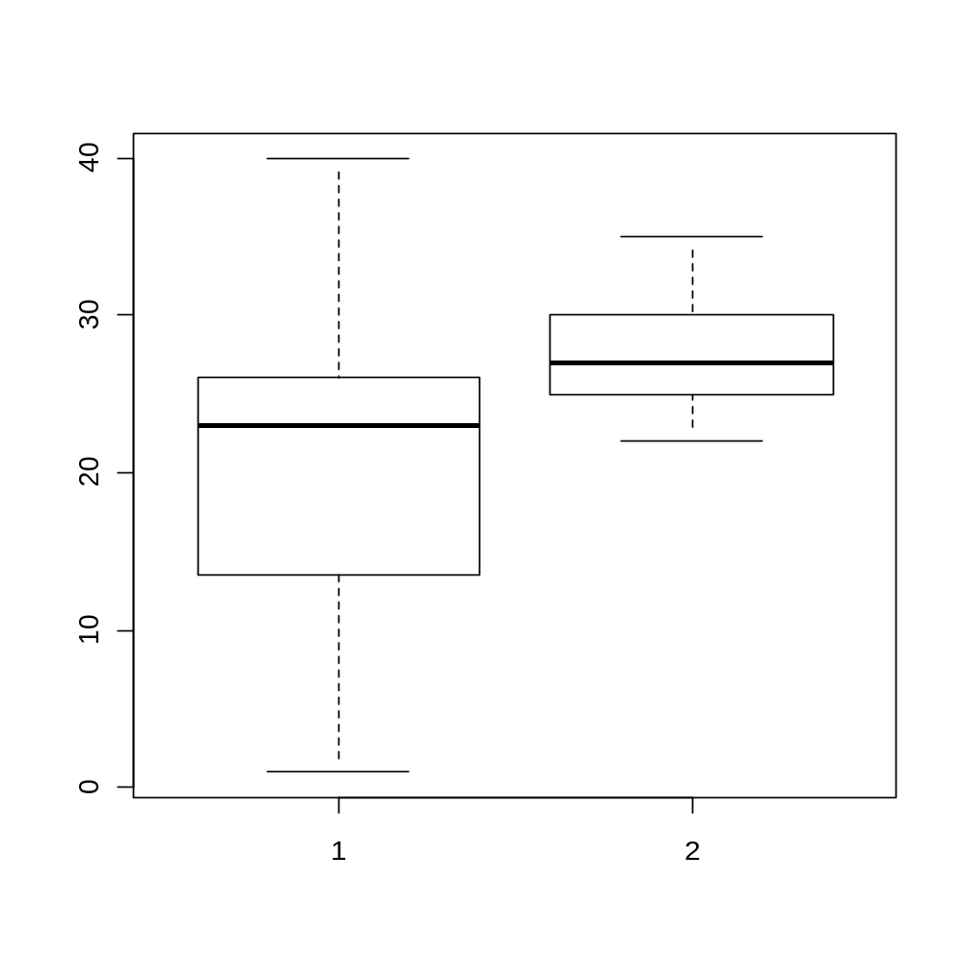
Figure 7
You can see from these two boxplots that now we do not have any outliers.

